Q1. Identify the superclass and subclasses.
Answer: The superclass is Employee. The subclasses are FullTimeEmployee, PartTimeEmployee, and Manager.
Q2. Explain how inheritance reduces code duplication.
Answer: Inheritance allows subclasses to reuse the fields and methods of the parent class. This reduces repeated code.
Q3. Identify the method demonstrating polymorphism.
Answer: The calculateSalary() method demonstrates polymorphism because each subclass calculates salary differently.
Q4. Explain why @Override is used.
Answer: @Override shows that a subclass is redefining a method from its parent class. It also helps the compiler detect mistakes.
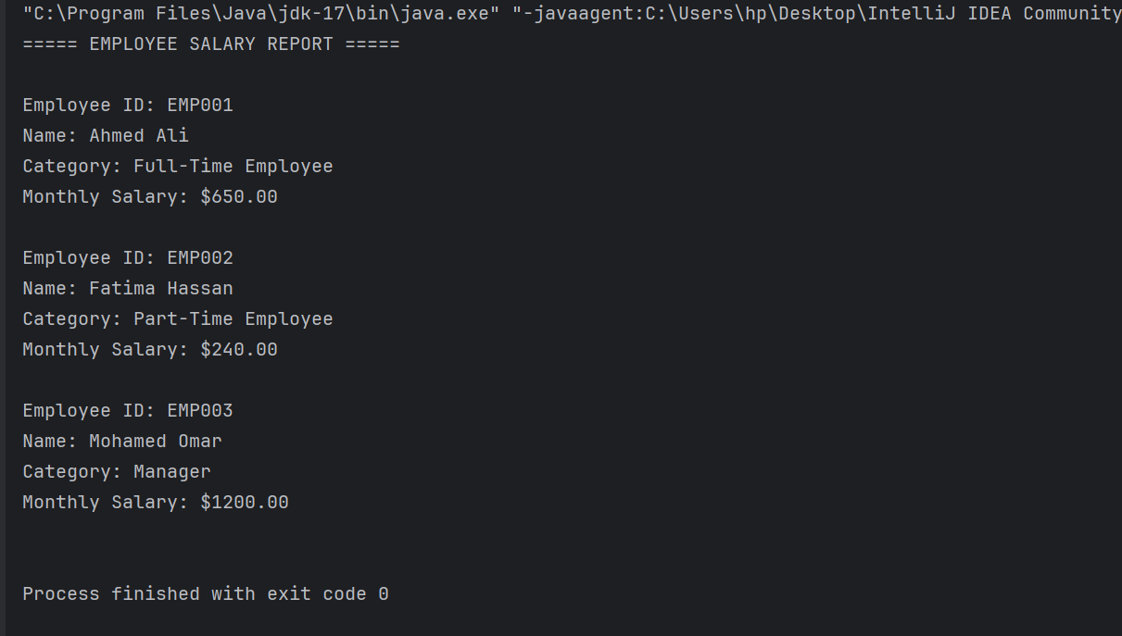

Q1. Why is MedicalService declared abstract?
Answer: MedicalService is declared abstract because it is a general class that defines common information and a method for all medical services.
Q2. Can an object be created directly from MedicalService? Explain.
Answer: No. We cannot create an object directly from an abstract class. We create objects from its concrete subclasses.
Q3. What is the difference between an abstract method and a concrete method?
Answer: An abstract method has no method body. A concrete method has a method body and contains code.
Q4. Why must each concrete subclass implement calculateTotalCost()?
Answer: Each subclass must implement calculateTotalCost() to calculate the total cost of its medical service.


